**#application**

**1)image restoration**

Partitioning method are use in image restoration ,restoration of image blurred image has been a fundamental problem in digital imaging for a long time.the field of image restoration has been of great interest in the scientific field.image restoration is done by partitioning method and its application in several scientific area including medical imaging and diagnosis,military surveillance,satellite imageing etc.

**2) Robotics:-**

In control robotics,non-collocated partial linearization is applied to underactuated mechanical system through inertia-decoupling regulators which employ a pseudoinverse as part of a modified input control law.

3)**Adaptive processing in radar:-**

Partition matrix is widely employedin several scientific technology application area .Toeplitz based covariance matrices are use to model structure properties for space-time multivariate adaptive processing in radar.

**4)wireless communication system:-**

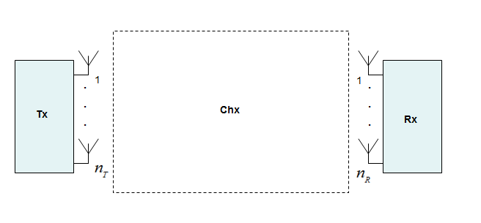

Tx—transmitior

Rx—receiver

Chx—channel

In the wireless communication ststem, there are three component in wireless communication system which is formaly known as transmitter,channel and reciver.transmiter transmit the singnal and receiver receved the signal .and signal are pass through channel.channel are represented in the form of matrix and that matrix are sloved by using partitioning method in very easy way.